

Student Name | Student Number
Lee Zhong De Rollei | A0079953L
Zhou Zi Feng

Human Computer Interface
Continuous Assessment 1
Team 13
Contents Page

1. Business Analysis 2
1.1 Back ground 2
1.2 Website Introduction 2
1.3 Website Success Matrix (Annual Basis) 2

2. User Profile 3
2.1 User Profile 1 - BackPacker 3
2.1.1 Persona 3
2.1.2 Scenario 3
2.2 User Profile 2 – Sports Traveler 4
2.2.1 Persona 4
2.2.2 Scenario 4

3. Wireframe 5
3.1 Default 5
3.2 Customized Home Page 5
3.3 Page Template 7

4. Sitmap 8

5. Prototype 8
5.1 Default Page 9
5.2 Back Packer Plan a Trip 10
5.2.2 Create New BackPack Trip 11
5.2.3 Add Destination/Hostel/Transport 12
5.2.4 Plan Itinerary 13

6. Usability Survey 14
6.1 Backpacker plans a trip 14

1. Business Analysis

Back ground
Today there are numerous websites providing accommodations and transports bookings. These websites typically provides advance search for hotels or flights. However, travelers today come with different profiles. They could be business travelers, sports travelers or backpackers. They need a

Website Introduction
We created “travelner.com (traveler planner)”, a website that could help busy travelers to plan and book their trips based on their trip purpose.

Website Success Matrix (Annual Basis)

s/n | Scenario | Points
s/n | Scenario | 1 | 2 | 3 | 4 | 5
1 | Number of visitors | >10000 | >20000 | >20000 | >50000 | 510000
2 | Number of Subscribers | >250 | >500 | >750 | >1000 | >1500
3 | Number of bookings | >500 | >1000 | >1500 | >2000 | >3000
4 | Number of return customers | >250 | >500 | >750 | >1000 | >1500
5 | Number of subscribers that uses the planning feature of the website | >250 | >500 | >750 | >1000 | >1500
6 | Number of abandon Shopping carts | >1500 | >1000 | >750 | >500 | >250

2. User Profile
Two profiles have been shortlisted for usability testing.

2.1 User Profile 1 - BackPacker

2.1.1 Persona

Yew Ming is an IT profession working in a bank. He is single and likes adventurous and exciting holiday trips
To prepare for his trips, Yew Ming will find out the information about the places that he will be visiting. Such information include, places of interest, accommodation, cultures, weathers and languages through reading travel books(e.g. lonely planet), internet forum such as tripadvisor, blogs etc.
ZhongDe prefers to travel more and pay less, as such most of his trips are done in backpacking manner

2.1.2 Scenario

This year end, zhongde decided to visit Taiwan. He started by visiting Zuji.com. At zuji.com, he could find cheap air tickets and accommodation. ZhongDe do not have a preference for any airlines and he is flexible with the travelling dates, but he hopes to get the cheapest air tickets with reasonably departure and arrival time slot (i.e. arrival time close accommodation check in time and departure time close to check out time)

2.2 User Profile 2 – Sports Traveler

2.2.1 Persona

2.2.2 Scenario

3. Wireframe

3.1 Default

Company
Logo
New User Start Here
Existing User Login Here
Footer

3.2 Customized Home Page
Company
Logo
Type of Traveler
Customized
Featured
Package
Global Hotel/Flight Search
Local Menu1
Local Menu2
Local Menu3
Footer
External Links
Customized
Content 1
Customized
Content 2
Why Us?

3.3 Page Template
Local Menu2
Breadcrumb
Pages
Company
Logo
Type of Traveler
Footer
Menu1
Pages
Local Menu2
Local Menu3
Selected
Page Content

4. Sitmap
Default
Back
Packer
Home Page
Concerts
Travelers
Home Page
Family
Travelers
Home Page
Business
Travelers
Home Page
Customized Home Page
Sports
Travelers
Home Page
- Home
- Plan Trips
- BackPack Packages
- BackPacking Tips
- BackPack Blogs
- Plan New Trip
- Trip 1
- Hotel/Transport
- Itinerary
- Payment
- BackPack Forums

5. Prototype

5.1 Default Page
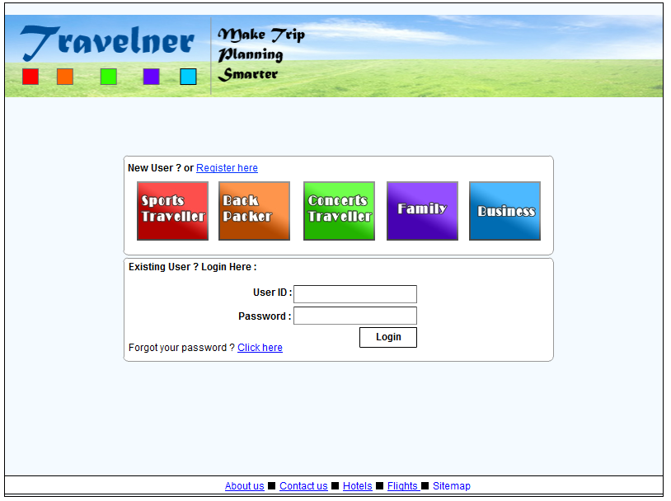

5.2 Back Packer Plan a Trip
5.2.1 Back Packer Home Page
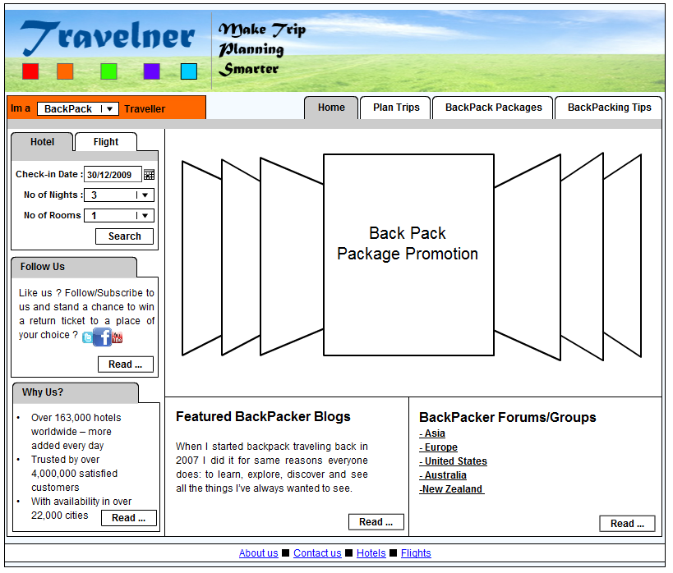

5.2.2 Create New BackPack Trip
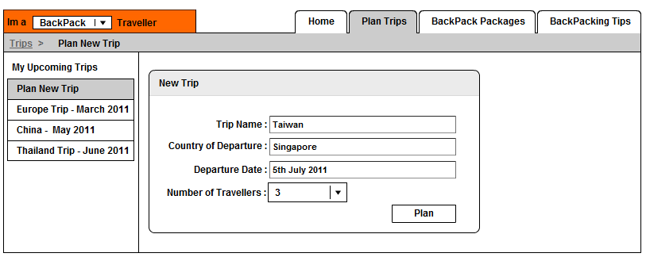

5.2.3 Add Destination/Hostel/Transport

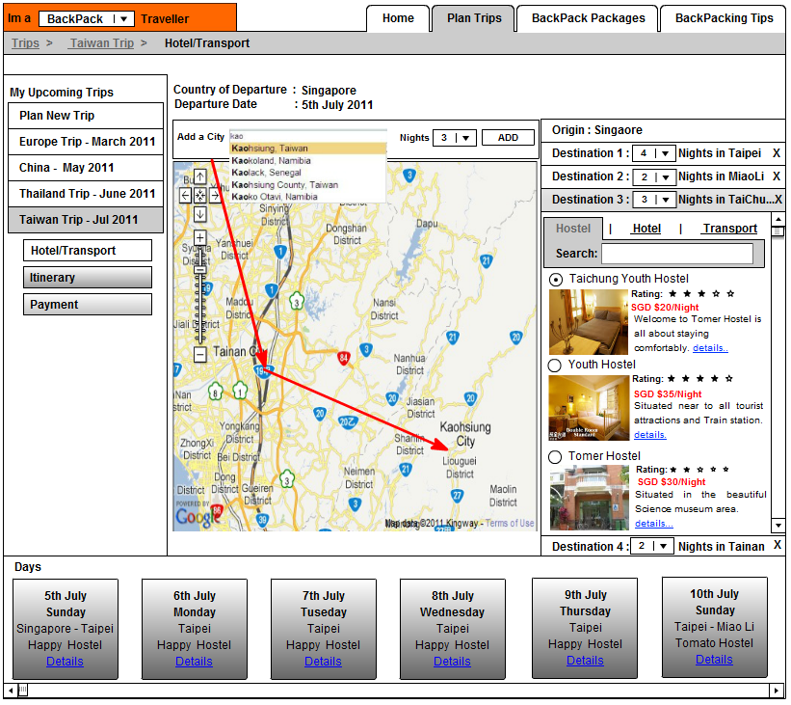

5.2.4 Plan Itinerary
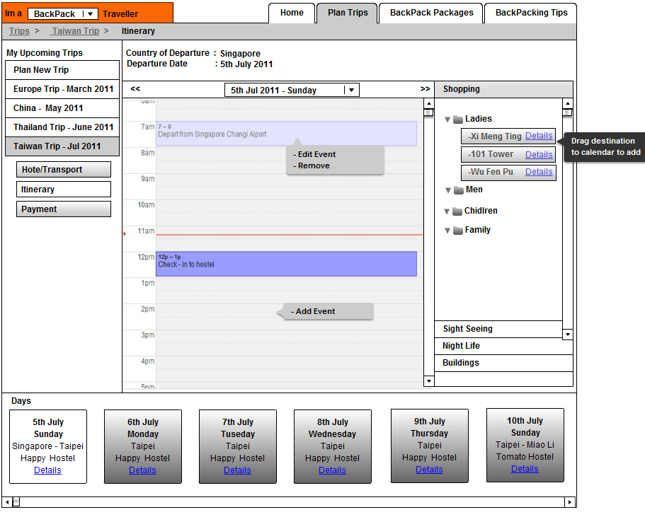

6. Usability Survey

6.1 Backpacker plans a trip
Survey Instruction
You want to go on a back pack trip to several places in Taiwan. You know planning will be a hassle because of the numerous places you wished to cover during your trip. You visited travelner.com for the first time as you heard from a friend that they provide trip planning service for free.
Based on the screen prototype provided, you need to describe how you could navigate the website to complete the following task. For each task completed, you need to describe any difficulty you encountered and also record the time you take to complete the task.
S/N | Task | Difficulties Encountered | Duration (in Seconds)
S/N | Task | Difficulties Encountered | < 5 secs | >5 secs | >10 secs
1 | You are at the BackPacker home page now. You need to start planning your trip.
2 | You need to add destinations to your trip
3 | You need to choose a transportation for each of your destination
4 | You need to choose your accommodation
5 | You need to plan your activities. By using any calendar you might find and add a event to your calendar
6 | You need to make payment for the hotels and accommodation you have selected

